Stable Angina

Definitions

1. Ischemia: decrease in blood flow
2. Coronary Artery Disease (CAD): Formation of **plaque** within coronary arteries🡪 less blood flow
3. Acute Coronary Syndrome (ACS):  is almost always associated with rupture of an atherosclerotic plaque and partial or complete thrombosis of the infarct-related artery
   1. Angina pectoris: chest pain (CP) (b/c of myocardial ischemia)
      1. Angina: Angere = to choke
      2. Unstable Angina (USA)
   2. Myocardial infarction (MI): dead tissue
   3. Arrhythmias
   4. Congestive Heart Failure (CHF)
4. Angina
   1. Stable Angina: Pattern associated with certain lvl of physical activity
   2. Unstable Angina: Change in angina intensity 🡪 go to ER
   3. Silent ischemia: b/c of diabetes maybe
   4. Prinzmetal’s variant: spasm of coronary artery
      1. Usually in the morning at rest

Epidemiology (disease stats)

1. CHD: 9.1 million out of 16 million have stable angina (57%)
   1. Chronic stable angina = 50% patients

Coronary Anatomy

1. Left Coronary Artery
   1. Supplies: left ventricle
   2. Sub divides into
      1. Left anterior descending (LAD)
      2. Left Circumflex (LC)
2. Right Coronary Artery
   1. Supplies: Right ventricle, left ventricle and SA node
   2. Sub divides into: a lot

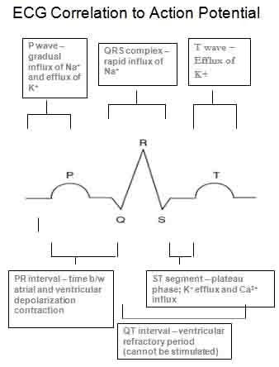Diagnostic Testing

1. ECG
   1. Ischemia: T wave inversion or ST segment depression
   2. Infarction: ST segment elevation
2. ETT (exercise tolerance testing)Stress tested to induce ischemia
   1. Treadmill: <80% max HR 🡪 CP and ECG change
3. Catheterization
   1. Radiocontrast dye injected
   2. No dye = plaque present
4. Myocardial Imaging 🡪 use Echo-ultrasound cardiographic
   1. Drugs to achieve stress
      1. Dobutamine (Beta Agonist) 🡪 increase HR
      2. Dipyridamole 🡪 vasodilator (of healthy)
      3. Adenosine 🡪 vasodilator
   2. Scintigraphy: nuclear medicine
      1. Inject thallium 🡪 indicate area of infraction
         1. Bind to Na/K pump
         2. Infarct has no thallium binded

Drug Therapy: Beta Blockers (1st line treatment)

1. For long term treatment
2. Decrease HR --> decrease MVO2 demand (does not improve MVO2 supply)
3. Objective : reduce HR to 50-60 bpm
4. Drugs: Nonselective
   1. CAPP
      1. Carteolol
      2. Acebutolol
      3. Penbutolol
      4. Pindolol

**Beta-blockers**

**SELECTIVE Daily Dose(mg/d) #Daily Doses/day ISA**

Atenolol (Tenormin®) 50-200 1 no

Metoprolol* (Lopressor®) 100-400 2 no

Metoprolol XL* (Toprol XL®) 100-400 1 no

Acebutolol (Sectral®) 400-1200 2 yes

Betaxolol (Kerlone®) 5-20 1 no

Bisoprolol (Zebeta®) 2.5-20 1 no

For Metoprolol, same max daily dose when switching short-acting and long-acting

**NON-SELECTIVE Daily Dose(mg/d) #Daily Doses/day ISA**

Nadolol (Corgard®) 40-240 1 no

Propranolol (Inderal®) 80-320 2-4 no

Propranolol LA (Inderal LA®) 80-320 1 no

Timolol (Blocadren®) 20-40 2 no

Pindolol (Visken®) 10-60 2 yes

Carvedilol (Coreg®) 50-100 2 no

1. Contraindications
   1. AV block (w/o pacemaker)
   2. Acute heart failure (beta is good for long term)
   3. Too low BP 🡪 systolic <90

Nitrates (2nd line)

1. Increase cGMP 🡪 vasodilation 🡪 decrease preload and afterload
   1. 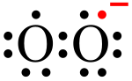Decrease afterload
   2. Increase O2
2. Tolerance
   1. Increase NO increase superoxide anion (constrictor)
   2. Solution: intervals

|  |  |  |  |  |
| --- | --- | --- | --- | --- |
|  | Dosage Form | Onset(min) | Duration | Dose |
| Nitro  Glycerin (NTG) | IV infusion (hospital)  (for pts with acute attack and HTN) | 1-2 | 3-5 min | 5-100mcg/min |
| **Sublingual (for acute relief)** | **1-3** | **10-30 min** | **0.4-0.6mg**  **(0.4 mg most popular dose)** |
| Translingual spray | 2-4 | 10-30 min | 0.4mg metered dose |
| Transmucosal,buccal | 2-5 | 3-6hrs | 1-3mg every 3-5hr |
| Oral, SR | 30 | 4-8hrs | 6.5-9mg 3times/day |
| **Topical, oint**  **(skin absorption can cause headache)** | **30** | **4-8hrs** | **1-2” q 4-6 hrs** |
| **Transdermal,patch**  **(long acting for recurrence prevention)** | **30-60** | **4->8 hrs** | **0.1-0.8mg/hr patch/day\*** |
| Isosorbide dinitrate (administer 2-3x/d; last dose **no later than 7pm** 🡪 to have a nitrate-free interval) | Sublingual | 2-5 | 2-4hrs | 2.5-10mg every 2-4hr |
| Chewable | 2-5 | 1-4hrs | 5-10mg q 2-4hr |
| Oral | 15-40 | 2-6hrs | 10-60mg q 4-6hr |
| Oral, SR | 15-40 | 4-8hrs | 40-80mg q 6-8hr |
| Isosorbide mono  Nitrate | Oral (ISMO) | 30-60 | 7-8hrs | 20-40mg bid (7hrs apart)—exact doses |
| Oral, SR (IMDUR) | 30-60 | 8-12 hrs | 30-120mg q daily (30,60,120) |

Calcium Channel Blockers CCB (class IV anti-arrhythmic)

1. 1st line treatment for **Vasospastic Angina** Variant angina
2. 2nd line treat ment for stable angina
3. Block voltage-gated calcium channels Decrease contractility
4. Drugs:
   1. Verapamil
   2. Diltiazem
   3. -dipine

**Calcium Channel Blockers**

Dihydropyridines Daily Dose(mg/d) #Doses/day

Nifedipine XL (Procardia XL®) 30-180 1

Amlodipine (Norvasc®) 2.5-10 1

Felodipine (Plendil®) 2.5-20 1

Nicardipine SR (Cardene® SR) 60-120 2

Non-Dihydropyridines Daily Dose(mg/d) #Doses/day

Verapamil (Calan®) 160-480 3-4

Verapamil ER (Covera HS®) 180-420 1

Diltiazem ER (Cartia XT®) 120-480 1

Diltiazem ER (Tiazac®) 120-540 1

Ranolazine (Ranexa)

1. Treat: Chronic Angina
   1. Patients whose BP or HR cannot be lowered
2. Dosing
   1. 500 mg bid moderate CYP3A inhibitors
3. ADR:
   1. QT prolongation
   2. CYP inhibitor ketoconazole,clarithromycin, nefazodone, nelfinavir

ACE inhibitors

1. 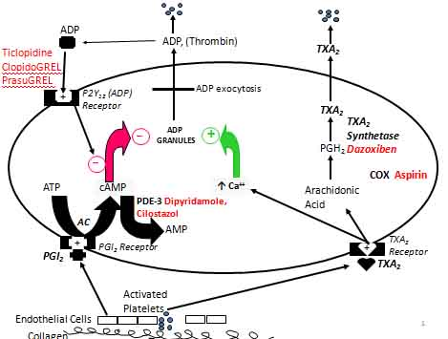Prevent rupture of plaques reduce inflammatory process of atherosclerosis

Aspirin

1. 33% reduction out of 3000 patients with chronic stable angina

Thienopyridine

1. Use: if allergic to Aspirin
2. Drug
   1. Clopidogrel: 74 mg qd
   2. Ticlopidine
3. Dring interaction
   1. **Cl**opidogrel + PPI
      1. b/c of CYP2**C1**9